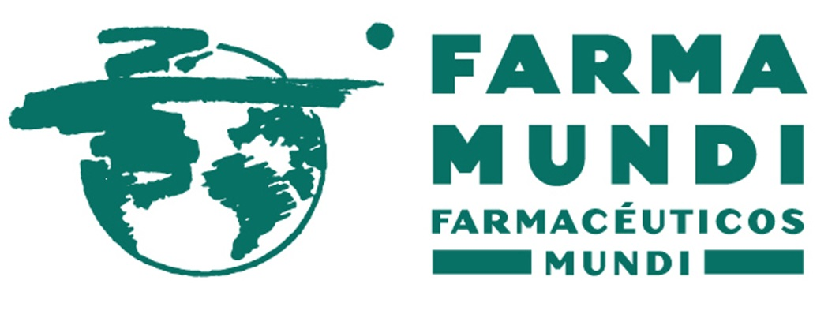

FARMACÉUTICOS MUNDI - TABLAS SALARIALES 2018
GRUPO | SALARIO BASE MENSUAL | SALARIO BASE ANUAL
0 | 1.825,23 € | 25.553,22 €
1 | 1.528,69 € | 21.401,66 €
2 | 1.366,79 € | 19.135,06 €
3 | 1.205,56 € | 16.877,84 €
4 | 1.040,53 € | 14.567,42 €

